1. **Describe the interior of earth?**

**Ans:**

The diameter of Earth is about 12,700 km. The temperature and pressure increases as one penetrates deeper and deeper. The core temperature is assumed to be 5000–6000°K. Earth comprises three concentric regions:

* 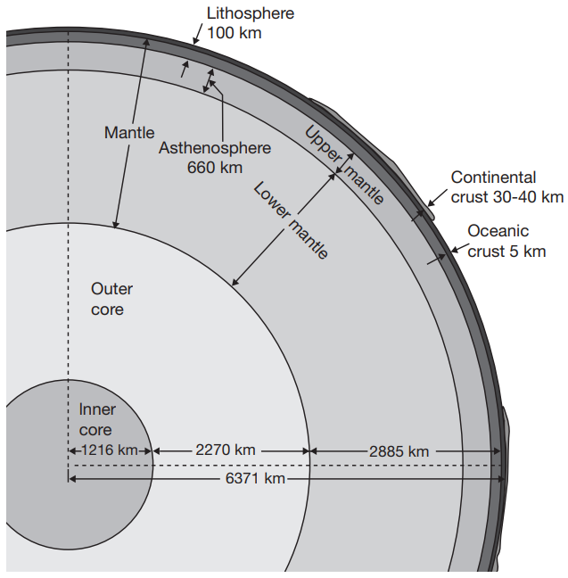**Core:** The core of approximately 7,000 km diameter is divided into inner core and outer core. The solid inner core has a radius of 1,216 km and density of 13 grams/cc. The liquid outer core has an average thickness of 2,270 km and density of 11 grams/cc. The core is supposed to be composed of an iron and nickel alloy. About 10 per cent of the layer is supposed to be composed of sulphur and oxygen as these elements are abundant in the cosmos and dissolve readily in molten iron.
* **Mantle:** The middle layer is the mantle which is about 2,900 km thick. The upper mantle of 660– 670 km thickness from the base of the crust, mostly contain olivine and pyroxene minerals. The asthenosphere, lying at a depth of 100–200 km from the Earth’s surface, is a weak and deformed layer, which acts as a lubricant for the plate tectonics to glide and may extend up to 660 km. The lower mantle stretches from 670 km to 2,900 km below the Earth’s surface. The lower mantle probably comprises silicon, magnesium and oxygen along with some iron, calcium and aluminum.
* **Crust:** The outer most part of Earth is the crust. Outer crust or continental crust may be 30 to 40 km in thickness containing mostly granite rocks with a density of 2.7grams/cc. The predominant elements are silicon and aluminum, hence is known as Sial layer. The inner crust or oceanic crust is only 5 to 10 km thick containing basaltic rocks with an average density of 3.0 grams/ cc. This layer contains silicon and magnesium and hence is known as Sima layer. Six major plates (Eurasian, American, African, Indo-Australian and Pacific) and twenty minor plates are involved in plate tectonics.
* **Lithosphere:** Lithosphere is a 100 km thick layer comprising the crust and the upper part of asthenosphere that can glide over the rest of the mantle. This is the region of earthquakes, volcanic eruptions, building of mountains and continental drifts. It exhibits various topographical features like continents, oceans, seas, lakes, mountains, plateau, plains, deltas, beaches, cliffs and dunes. It comprises rocks (igneous, sedimentary and metamorphic rocks) that contain all the minerals (dolomite, magnetite, hematite, etc.) and elements (iron, nickel, nitrogen, hydrogen, oxygen, sulphur, phosphorus, etc.) needed for our survival and prosperity. The rocks turn into soil by pedogenesis, which sustains the biota.

1. **What is the study of environmental sciences?**

**Ans:**

Environmental science is an integral process, which deal with his natural and man made surroundings, including the relation of population growth, pollution, resource allocation and depletion, conservation, technology, urban and rural planning to the total human environment. Environmental science is a study of the factors influencing ecosystems, mental and physical health, living and working conditions, decaying cities and population pressures. Environmental science is intended to promote among citizens the awareness and understanding of the environment, Our relationship to it, and the concern and responsible action necessary to assure our survival and to improve the quality of life.

* Importance of environmental study:

The objective of environmental study is to make public aware about environmental problem, and importance of environmental protection. Environmental science is important from the following view points:

* It gives us the basic understanding about various aspects of environment and its associated problems.
* It teaches us the concept of sustainable development.
* It gives and idea about beneficial use of natural resources without damaging it much.
* It imparts the knowledge of ecofriendly techniques to be used in various fields.
* It helps to promote the use of non-conventional energy, wind energy, biomass energy etc.
* It teaches us how to conserve energy and save our planet.
* It teach us about bad effects of pollution and suggest measures to minimize environmental pollution.
* It helps us to unde3rstand about ecological imbalance and various ways to maintain ecological balance.
* It gives the knowledge about interdependency of man and nature.
* It develops skills to identify environmental problems and their solutions.
* Objectives of environmental science:

1. To increase awareness and sensitivity to the environment among the people.
2. To increase the knowledge of environment.
3. To improve attitude towards the environment.
4. Ito acquire skills for solving environmental problems.
5. To increase participation and to develop a sense of responsibility.

* Principles of environmental education:

The major principles of environmental study are as follows:

* Environmental study considers environment in its totality.
* Environmental study is not a one short learning approach. It is a challenging area requiring both disciplinary and interdisciplinary approach. This calls for a holistic rather than a piece meal subject oriented approach.
* Environmental hazards are controllable and every citizens has a moral obligation and responsibility towards this.
* Concern of environment are concerns of several agencies. Formal and nonformal education system and programmers must work in unison.
* Education must cater to all sections of society the general public, and non specialists, socio professional groups and technologists as well.
* Promote the value and necessity of local, notional and interpersonal cooperation in the prevention of and solution to environmental problems.
* To appreciate the gifts of the nature
* Help learners discover the symptoms and causes of environmental problems.
* To promote the value and necessity of local, national, international cooperation in the prevention and solution of environmental problems.

1. **Describe the major component or sphere of environment with diagram?**

**Ans:**

Environment is the some of all social, economical, biological, physical and chemical factors which constitute the surrounding. The natural environment of a living organism can be divided into three components:

1. Biotic component: its consists of all the living organisms present within the environment.
2. Abiotic component: all the other substances except living organisms are known as abiotic components. The abiotic components broadly consist of atmosphere (air), hydrosphere (water) and lithosphere (soil).
3. Energy component: the energy component may be solar energy, geo-chemical energy, thermoelectrical energy, hydro-electrical energy, atomic energy and energy due to radiation.

* Elements of environment:

All the abiotic and biotic environments can be classified into four different segments depending upon their physical, chemical and biological characteristics. These are:

**Atmosphere**

Atmosphere is a multi-layered envelope of different gases surrounding the earth which holds up life on earth and save it from harmful environment of outer space. It extends to a height of about 1600 km. from the earth’s surface.

* Composition of atmosphere:

A pollution free atmosphere has three categories of constituents: 1) Major components. 2) Minor components. 3) trace component.

The composition of dry atmosphere at ground level below a height of 25km may be expressed as percentage by percentage by volume as given in table:

|  |  |  |
| --- | --- | --- |
| **Components** | **Gas** | **Volume % (Dry air)** |
| Major components | Nitrogen | 78.08% |
| Oxygen | 20.94% |
| Minor components | Argon | 0.93% |
| Carbon-dioxide | 0.03% |
| Trace components | Neon | 0.0018% |
| Helium | 0.000524% |
| Ozone | 0.000001% |
| Hydrogen | 0.00005% |
| Krypton | 0.000114% |
| Xenon | 0.0000087% |
| Methane | 0.0002% |
| Nitrous oxide | 0.00005% |

* Structure of atmosphere:

Depending upon the physical characteristics such as temperature, density etc. the atmosphere is divided into five concentric layers. These are:

1. Troposphere:

* It is the lower most layer of atmosphere in which most living organisms exist.
* It extends up to 8 km at the poles and 16km at equator.
* It is characterized by a steady decrease in temperature with increase in height at the rate of about 6.5o C per km.
* At the upper most layer of troposphere, the temperature may go down to 60o C.
* It contains mostly nitrogen, oxygen and carbon dioxide along with traces of other inert gases.

1. Stratosphere:

* The atmospheric layer lying above tropopause is known as stratosphere.
* The thickness of stratosphere is about 62 kms. at the equator, 72kms. at the poles and extends up to 80kns from the surface of the earth.
* The temperature of this layer varies between -55o C to 5oC and it increase with the increase in altitude.
* The major component of this layer is called as ozonesphere within stratosphere. It absorb UV rays of sun and protects the living world from the UV radiation.

1. Mesosphere:

* Mesosphere is above stratosphere and it extends upto 80-90 kms above the earth surface.
* The temperature of this layer decrease with the increase in altitude and reaches the minimum of -95o C at the highest border.
* This layer is also characterize by very low pressure.

1. Ionosphere/ thermosphere:

* 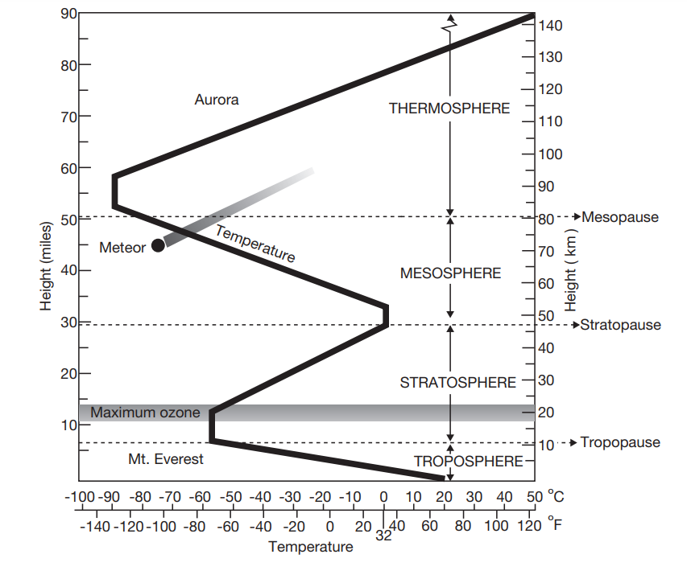 This layer is above the mesosphere and it extends up to 500kms above the earth surface.
* With increase in altitude, the temperature of this layer increases.
* The UV and cosmic radiation of sun causes ionization of the molecules or atoms present within this layer, giving a large number of ions.

1. Exosphere:

* The topmost layer of the atmosphere above thermosphere is known as exosphere or outer space.
* This layer extends up to 1600kms from the earth’s surface.
* Since it is nearer to sun, its temperature is very high.

**Hydrosphere**

All types of water resources, namely the oceans, seas, rivers, lakes, ponds, reservoirs, polar ice caps, glaciers, ground water and water vapour are collectively known as the hydrosphere.

The hydrosphere is an important part of the earth’s surface. About 70% of the earth’s surface is covered with water. The northern hemisphere is dominated by land surface, while the southern hemisphere is almost entirely occupied by water bodies (oceans).

The distribution of water is as under:

97% ------------------- oceans and seas

2% -------------------- in ice caps at polar regions

0.75% ---------------- as ground water.

0.25 % --------------- lakes, ponds, rivers, streams.

Total quantity of water available on the earth surface is about 1.4 billion km3 and if this amount is spread over the earth surface, then it will form 2.5 km deep water mass.

**Lithosphere**

The upper layer of the earth’s crust is called lithosphere. It is made up of soil, minerals, rocks and other organic as well as inorganic matter. Rocks are subjected to continuous physical chemical and biological weathering. Plants grow and decay on the soil covering the rocks . soil is the major component of the lithosphere; the organic matter in soil is decomposed by micro organisms thus forming biomass. The biomass is mixed with the soil fauna. The major components of the soil are sir, water, minerals and organic matter obtained from weathering of the parent rock. Soil plays a vital role in supplying nutrients to the plant kingdom. The thickness of lithosphere ranges from 64 to 96km. the uppermost part of the lithosphere is rich in silica (Si) and aluminum (Al) and is therefore, known as the SiAl layer.

**Biosphere**

It is that portion of earth’s surface, hydrosphere and atmosphere where life exists. Biosphere is a biological environment where living organisms interact with physical environment, e.g. soil, water and air. It extends from the lowest sea bed level to about 24 km of the atmosphere.

From the bottom of the sea level to the surface of the earth, whether it is desert, grass land, hills, wells, rivers, lakes or even sky where the birds and other small creatures are existing are included in biosphere. Every living organism is getting the all basic resources from the biosphere i.e. air, water food and sunlight etc. and simultaneously the waste in the form of solid, liquid or gases produced by it are discharged into the biosphere. Biosphere has a capacity to absorb, convert or dilute the waste and make it useful once again to the next generation of organism.

1. **Interaction among components of environment?**

**Ans:**

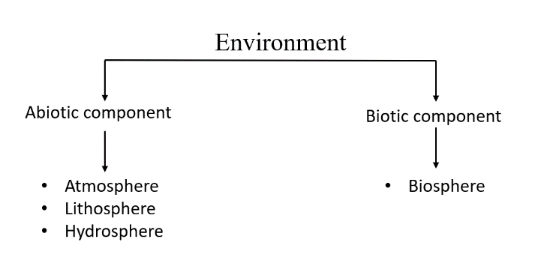Two major components of environment are biotic and abiotic.

This fig shows a schematic rep of the four environmental components and their interrelationship. The circles represent the spheres and the curved arrows indicate the flow path of matter. All the spheres have two way linkage to other sphere including itself which represent the transfer of matter from one sphere to other or within itself without leaving the sphere.

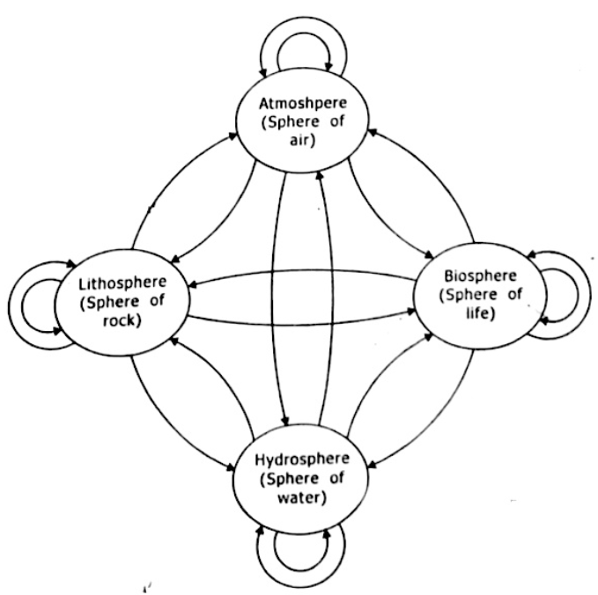The atmosphere may be considered as a transport component that moves substances from atmospheric sources to the receptors. Its storage capacity is small compared to the other spheres but it has greater capacity for spatially redistributing matter.

The hydrosphere has two subcomponents i.e. rivers and oceans. The river system collects the substances within the watershed and delivers them to the second subcomponent that is ocean.

The lithosphere is a composed of soil particles and rocks within the soil, biochemical reactions by microorganisms are responsible for most of the chemical changes of matter. However, soil and rock are mainly storage components for deposited matter.

All the components of environment are interrelated with each other. Any change in one of the components affect other components also. For example, changes in the temperature of atmosphere, cause changes in the rate of evaporation, humidity in atmosphere and after saturation of humidity when rainfall takes place, it affects lithosphere as flood may occur causing erosion of earth. This also affects the biosphere as different types of plants grow differently according to the amount of rainfall they receive.

Lithosphere is almost static component of environment while atmosphere and hydrosphere are dynamic components of environment. Different types of movements in air due to wind and storms and movements of river water as well as ocean water cause changes on the land surface and thus affect the lithosphere.

1. **Define environment?**

**Ans:**

Literally speaking, environment means surrounding of a species, to which it remains totally adapted and to which it continuously interacts for its survival. Biologically, environment is the combination of factors and forces (like air, water, soil, light etc.) affecting the existence, growth and metabolism of organisms.

Environment can be defined in a number of ways:

1. Environment is the sum of all social, economical, biological, physical and chemical factors which constitute the surrounding.
2. Environment is the combination of all the organic and inorganic substances surrounding man.
3. Environment refers to the sum total of conditions which surround man at a given point in space and time. (C.C. PARK,1980)
4. The space we live in, the air we breath, the food we eat, the water we drink and other resources we need all these we draw form our environment. (K.R. Dikshit , 1984).
5. Environment is the representative of physical component of earth where man is the important factor influencing his environment (A. Gouche, 1984).

From the above definitions, it is clear that environment consists of inseparable whole system constituted by physical, chemical, biological and social elements which are inter-related in may respect.

1. **What is Biogeochemical cycle?**

**Ans:**

Definition: The cyclic movement of chemicals of the biosphere between the living organisms(biotic components) and non-living organisms (abiotic components) is known as biogeochemical cycle. Here bio means living organisms and geo means rocks, soil, air, water etc. and chemical refers to elements and compounds. Since the cyclic flow involves some living organisms and series of chemical reactions in the abiotic environment the cycles are called as biogeochemical cycle.

The organisms ranging from microbes to man, require about 30 to 40 elements for their growth and development. Carbohydrates are synthesized by green plants using CO2 and H2O. Other complex organic molecules are synthesized by the absorption of nutrients either from soil or from the atmosphere (abiotic component). The nutrient maybe micro nutrient which contain higher amount of elements like carbon, hydrogen, potassium, calcium, magnesium etc. or micro-nutrient which contains traces of iron, copper, zinc, molybdenum, cobalt etc. when the living organisms are dead, the decomposers of the ecosystem play a crucial role in decaying and disintegrating the complex organic molecules into simpler forms and finally release the nutrients into soil and environment. Thus, materials flow from abiotic (non-living environment) to biotic components (living organisms) and then by decomposition from living organisms into reservoir of non-living environment again in a more or less cyclic manner. In this taking and returning processes, a number or organisms and some physio-chemical phenomena are involved, which make together and orderly operating cycle. Thus, the movement (imports and exports) of minerals is accompanied by the operation of a number of cycles that keep on passing the materials back and forth in between organisms and their environment.

A bio-geochemical cycle involves two phases:

1. Organic or biotic phase: the passage of chemicals (mainly complex organic molecules) through the food chain is known as organic phase.
2. Inorganic or abiotic phase: From the release of chemical (inorganic compounds) by the decomposer up to the absorption by the producer, is known as inorganic or abiotic phase.
3. **What is endogenic and exogenic cycles?**

**Ans:**

There are two main types of materials cycles, such as:

1. 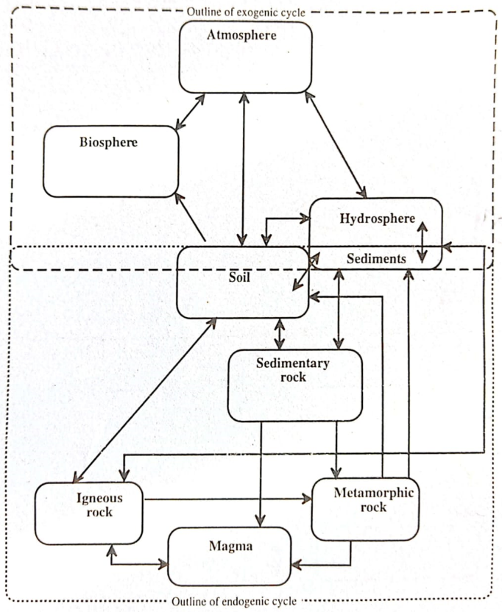exogenic cycles: It is occur largely on earth’s surface and usually have an atmospheric component. Sediment and soil can be viewed as being shared between the two cycles and constitute the predominant interface between them. Most biogeochemical cycles can be described as elemental cycles involving nutrient elements. Many are exogenic cycles in which the element in question spends part of the cycle in the atmosphere – O2 for oxygen cycle, N2 for nitrogen cycle, CO­2 for carbon cycle.
2. endogenic cycles: It is predominately involve subsurface rocks of various kinds. Sediment and soil can be viewed as being shared between the two cycles and constitute the predominant interface between them. Phosphorus cycle is a endogenic cycle form biogeochemical cycle. Because it doesn’t have a gaseous component. All sedimentary cycles involve salt solutions or soil solutions that contain dissolved substances leached from weathered mineral; these substances may be deposited as mineral formations, or

Fig: General outline of exogenic and endogenic cycle

the may be taken up by organisms as nutrients.

1. **What is carbon cycle? Explain with a diagram.**

**Ans:**

I will change something